727721euai034

MOHANA R

CIA1

Q1)

**import** org.openqa.selenium.By;

**import** org.openqa.selenium.Keys;

**import** org.openqa.selenium.WebDriver;

**import** org.openqa.selenium.chrome.ChromeDriver;

**import** org.openqa.selenium.chrome.ChromeOptions;

**import** io.github.bonigarcia.wdm.WebDriverManager;

**public** **class** CIA1_1

{

**public** **static** **void** main( String[] args ) **throws** InterruptedException

{

ChromeOptions co = **new** ChromeOptions();

co.addArguments("--remote-allow-origins=*");

WebDriverManager.*chromedriver*().setup();

WebDriver driver = **new** ChromeDriver(co);

driver.manage().window().maximize();

driver.get("https://www.amazon.in/dp/B0BY8JZ22K?ie=UTF8&ref_=tile1_OPCE3Lite&pf_rd_r=S5EQV3N10Q8DQ4F8GRYX&pf_rd_p=f9b21fd0-f4b0-4df8-8ed7-1a63a309f7ce&pd_rd_r=92dc3dfb-5330-4526-8123-2ec298750f3a&pd_rd_w=8tozG&pd_rd_wg=GzWLa&th=1");

String title = driver.getTitle();

String p_name = "OnePlus Nord CE 3 Lite 5G (Pastel Lime, 8GB RAM, 128GB Storage)";

System.***out***.println(title);

**if**(title.equals(p_name)) {

System.***out***.println("Title is matching");

}

**else** {

System.***out***.println("Title Mismatch");

}

driver.findElement(By.*xpath*("//*[@id=\"add-to-cart-button\"]")).click();

Thread.*sleep*(5000);

Boolean present = driver.findElement(By.*xpath*("//*[@id=\"attach-close_sideSheet-link\"]")).isDisplayed();

System.***out***.println("item added to cart:" + present);

driver.get("https://www.amazon.in/gp/cart/view.html/ref=dp_atch_dss_cart?");

Thread.*sleep*(5000);

driver.findElement(By.*xpath*("//*[@value=\"Delete\"]")).click();

Thread.*sleep*(5000);

String removeText = driver.findElement(By.*xpath*("//*[@id=\"sc-active-cart\"]/div/div[1]/div/h1")).getText();

String text = "Your Amazon Cart is empty.";

**if**(removeText.equals(text)) {

System.***out***.println("Product is removed");

}

driver.get("https://www.amazon.in/dp/B0BY8JZ22K?ie=UTF8&ref_=tile1_OPCE3Lite&pf_rd_r=S5EQV3N10Q8DQ4F8GRYX&pf_rd_p=f9b21fd0-f4b0-4df8-8ed7-1a63a309f7ce&pd_rd_r=92dc3dfb-5330-4526-8123-2ec298750f3a&pd_rd_w=8tozG&pd_rd_wg=GzWLa&th=1");

driver.findElement(By.*xpath*("//*[@id=\"add-to-cart-button\"]")).click();

Thread.*sleep*(2000);

driver.get("https://www.amazon.in/gp/cart/view.html/ref=dp_atch_dss_cart?");

Thread.*sleep*(5000);

driver.findElement(By.*xpath*("//*[@id=\"a-autoid-0-announce\"]")).click();

driver.findElement(By.*xpath*("//*[@id=\"quantity_2\"]")).click();

Thread.*sleep*(2000);

driver.findElement(By.*xpath*("/html/body/div[1]/div[2]/div[3]/div[5]/div/div[1]/div[1]/div/form/div/div[3]/span/span/span/input")).click();

Thread.*sleep*(1000);

driver.findElement(By.*xpath*("//*[@id=\"ap_email\"]")).sendKeys("mohanarajendran37@gmail.com",Keys.***ENTER***);

driver.findElement(By.*xpath*("//*[@id=\"ap_password\"]")).sendKeys("Saru@4049",Keys.***ENTER***);

String sign = driver.getTitle();

System.***out***.println(sign);

String esign = "Amazon Sign In";

**if**(sign.equals(esign)) {

System.***out***.println("Success");

}

**else** {

System.***out***.println("Failure");

}

}

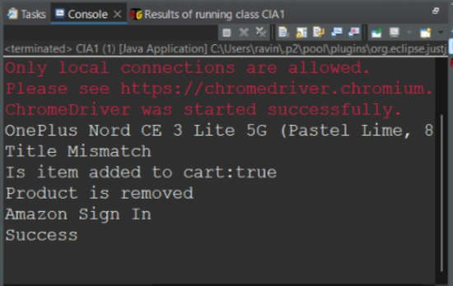

Q2)

**import** org.openqa.selenium.By;

**import** org.openqa.selenium.WebDriver;

**import** org.openqa.selenium.WebElement;

**import** org.openqa.selenium.chrome.ChromeDriver;

**import** org.openqa.selenium.chrome.ChromeOptions;

**import** io.github.bonigarcia.wdm.WebDriverManager;

**public** **class** CIA1_2 {

**public** **static** **void** main(String[] args) {

WebDriver driver;

WebDriverManager.*edgedriver*().setup();

driver=**new** EdgeDriver();

driver.get ("https://www.amazon.in/");

driver.manage().window().maximize() ;

String currentTitle=driver.getTitle();

System.***out***.println(currentTitle);

String expectedTitle="Online Shopping site in India: Shop Online for Mobiles, Books, Watches, Shoes and More - Amazon.in";

**if**(currentTitle.equals(expectedTitle)) {

System.***out***.println("Title Matched");

}

**else** {

System.***out***.println("Title not Matched");

}

WebElement txtBoxl=driver.findElement(By.*xpath*("//*[@id=\"twotabsearchtextbox\"]"));

txtBoxl.sendKeys("asus");

driver.findElement(By.*xpath*("//*[@id=\"nav-search-submit-button\"]")).click();

String txt1=driver.findElement(By.*xpath*("//*[@id=\"search\"]/div[1]/div[1]/div/span[1]/div[1]/div[3]/div/div/div/div/div/div/div/div[2]/div/div/div[1]/h2/a/span")).getText();

System.***out***.println(txt1);

String txt2=driver.findElement(By.*xpath*("//*[@id=\"search\"]/div[1]/div[1]/div/span[1]/div[1]/div[4]/div/div/div/div/div/div/div/div[2]/div/div/div[1]/h2/a/span")).getText();

System.***out***.println(txt2);

String txt3=driver.findElement(By.*xpath*("//*[@id=\"search\"]/div[1]/div[1]/div/span[1]/div[1]/div[5]/div/div/div/div/div/div[2]/div/div/div[1]/h2/a/span")).getText();

System.***out***.println(txt3);

String txt4=driver.findElement(By.*xpath*("//*[@id=\"search\"]/div[1]/div[1]/div/span[1]/div[1]/div[6]/div/div/div/div/div/div[2]/div/div/div[1]/h2/a/span")).getText();

System.***out***.println(txt4);

String txt5=driver.findElement(By.*xpath*("//*[@id=\"search\"]/div[1]/div[1]/div/span[1]/div[1]/div[7]/div/div/div/div/div/div[2]/div/div/div[1]/h2/a/span")).getText();

System.***out***.println(txt5);

//filter

driver.findElement(By.*xpath*("//*[@id=\"p_36/7252032031\"]/span/a/span")).click();

driver.findElement(By.*xpath*("//*[@id=\"p_n_pattern_browse-bin/1464446031\"]/span/a/span")).click();

}

}

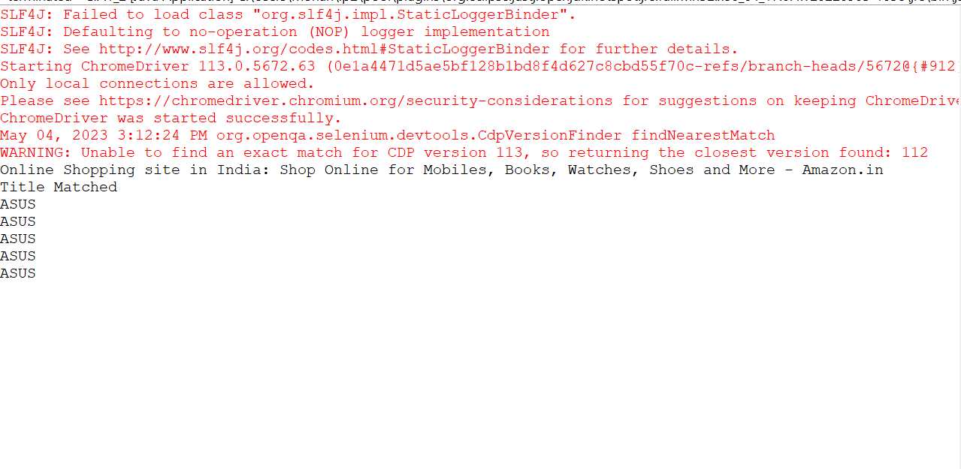

Q3)

**import** org.openqa.selenium.By;

**import** org.openqa.selenium.WebDriver;

**import** org.openqa.selenium.WebElement;

**import** org.openqa.selenium.edge.EdgeDriver;

**import** io.github.bonigarcia.wdm.WebDriverManager;

**public** **class** CIA1_3

{

**public** **static** **void** main(String[] args) {

WebDriver driver;

WebDriverManager.*edgedriver*().setup();

driver=**new** EdgeDriver();

driver.get ("https://www.amazon.in/");

driver.manage().window().maximize() ;

String currentTitle=driver.getTitle();

System.***out***.println(currentTitle);

String expectedTitle="Online Shopping site in India: Shop Online for Mobiles, Books, Watches, Shoes and More - Amazon.in";

**if**(currentTitle.equals(expectedTitle)) {

System.***out***.println("Title Matched");

}

**else** {

System.***out***.println("Title not Matched");

}

driver.findElement(By.*xpath*("//*[@id=\"nav-link-accountList\"]")).click();

WebElement txtBoxl=driver.findElement(By.*xpath*("//*[@id=\"ap_email\"]"));

txtBoxl.sendKeys("mohanarajendran37@gmail.com");

driver.findElement(By.*xpath*("//*[@id=\"continue\"]")).click();

WebElement txtBox2=driver.findElement(By.*xpath*("//*[@id=\"ap_password\"]"));

txtBox2.sendKeys("Saru@4049");

driver.findElement(By.*xpath*("//*[@id=\"signInSubmit\"]")).click();

driver.findElement(By.*xpath*("//*[@id=\"nav-link-accountList\"]")).click();

driver.findElement(By.*xpath*("//*[@id=\"a-page\"]/div[2]/div/div[2]/div[1]/a/div/div")).click();

driver.findElement(By.*xpath*("//*[@id=\"a-autoid-2-announce\"]")).click();

driver.findElement(By.*xpath*("//*[@id=\"ordersInPackage-container\"]/div/div/a[1]")).click();

}

}

